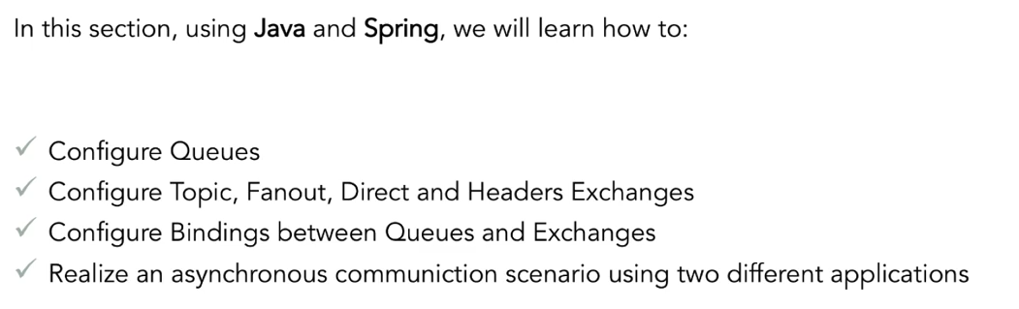

Creating Bindings Between Queues and Exchanges -----------------------

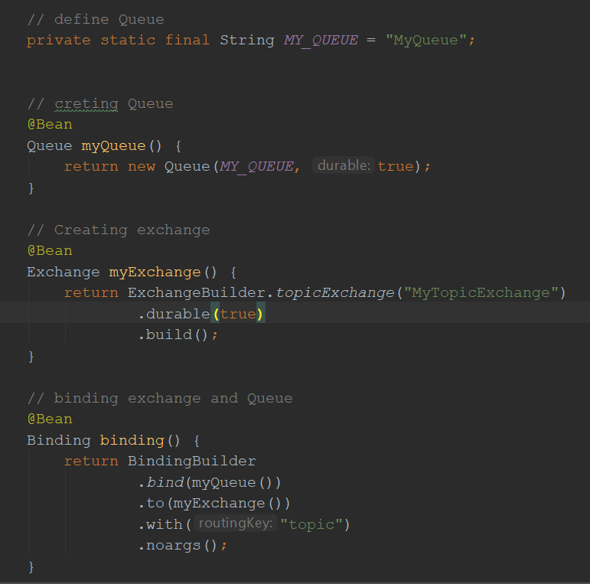

Scenario: Receiving and Processing Messages from Different Apps

What Have We Learned?

